SHOPSY E-COMMERCE DATABSE MANAGEMENT
SYSTEM
PRODUCT AND CATEGORY MANAGEMENT SYSTEM
1. Database Design :
The ShopSphere Online E-Commerce Database Management System uses Product and Category as important entities for managing products available on the e-commerce platform. The Category table stores information about different product categories, while the Product table stores product details such as product name, price, brand, stock quantity, and product description. The Product table is connected to the Category table using Category_ID, which establishes a one-to-many relationship between Category and Product.
1.1 Category Table :
Attribute | Key Type
Category_ID | Primary Key
Category_Name | Unique Key
Description | -
1.2 Product Table :
Attribute | Key Type
Product_ID | Primary Key
Product_Name | Not Null
Seller_ID | Foreign Key
Category_ID | Foreign Key
Price | -
Stock | -
Description | -
2. Primary and Foreign Key Relationships :
The relationship between Category and Product is defined using Category_ID.
- Category.Category_ID → Primary Key
- Product.Product_ID → Primary Key
- Product.Seller_ID → Foreign Key
- Product.Category_ID → Foreign Key referencing Category.Category_ID
- Relationship: One-to-Many (1:M)
- One category can contain many products, while each product belongs to a category.
3. Store Product Details and Table Creation :
The following SQL statements create the Category and Product tables and store product details such as product name, seller, category, price, stock, and description. The Category table stores category information, while the Product table stores the details of products available in the ShopSphere e-commerce system. The relationship between Category and Product is maintained using Category_ID, while Seller_ID is used as a foreign key in the Product table.
3.1 Create Category Table :
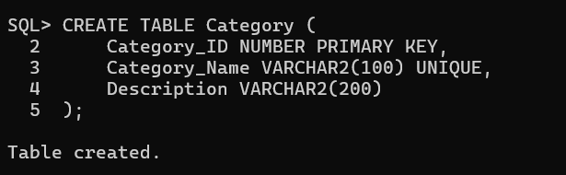
3.2 Create Product Table :
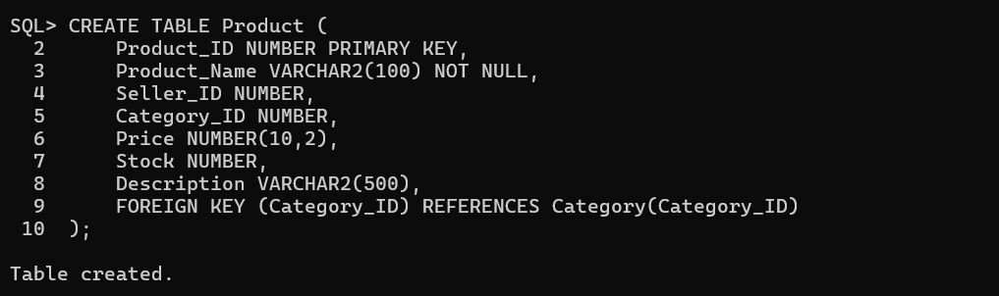
4. Product Insertion, Updating and Deletion :
4.1 Category Records :
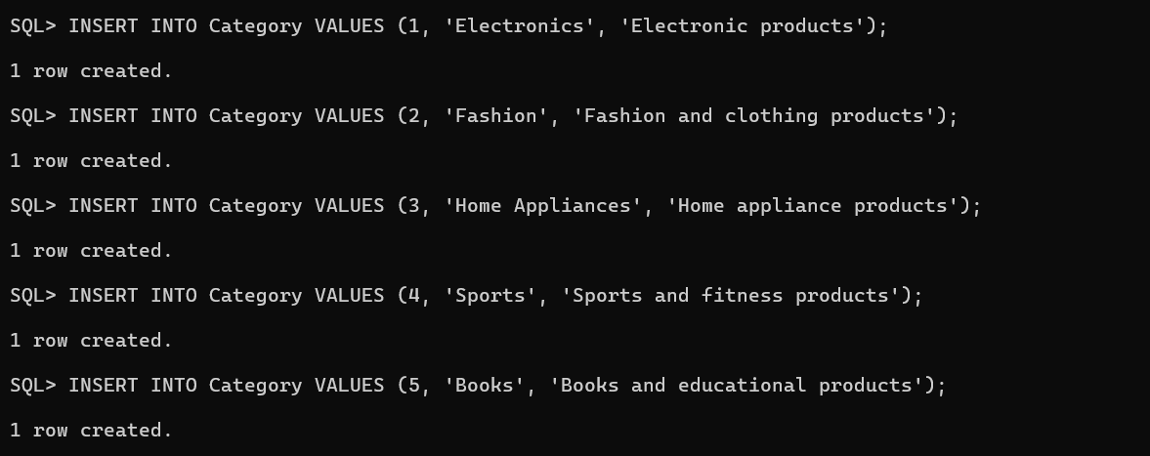
4.2 Product Records :
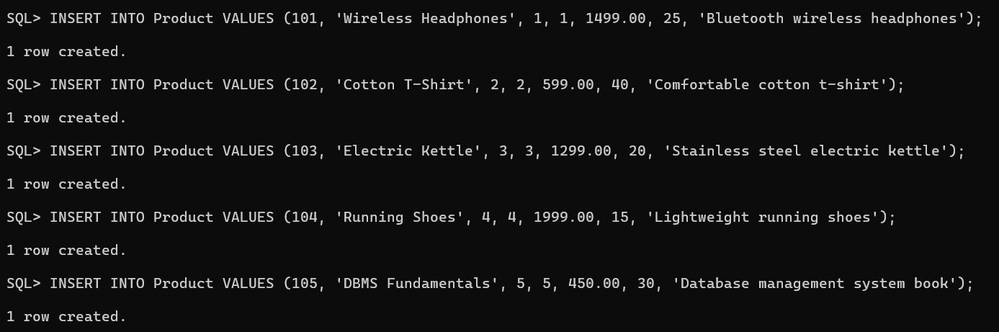
5.Data Retrival :
5.1 Display Category Records :
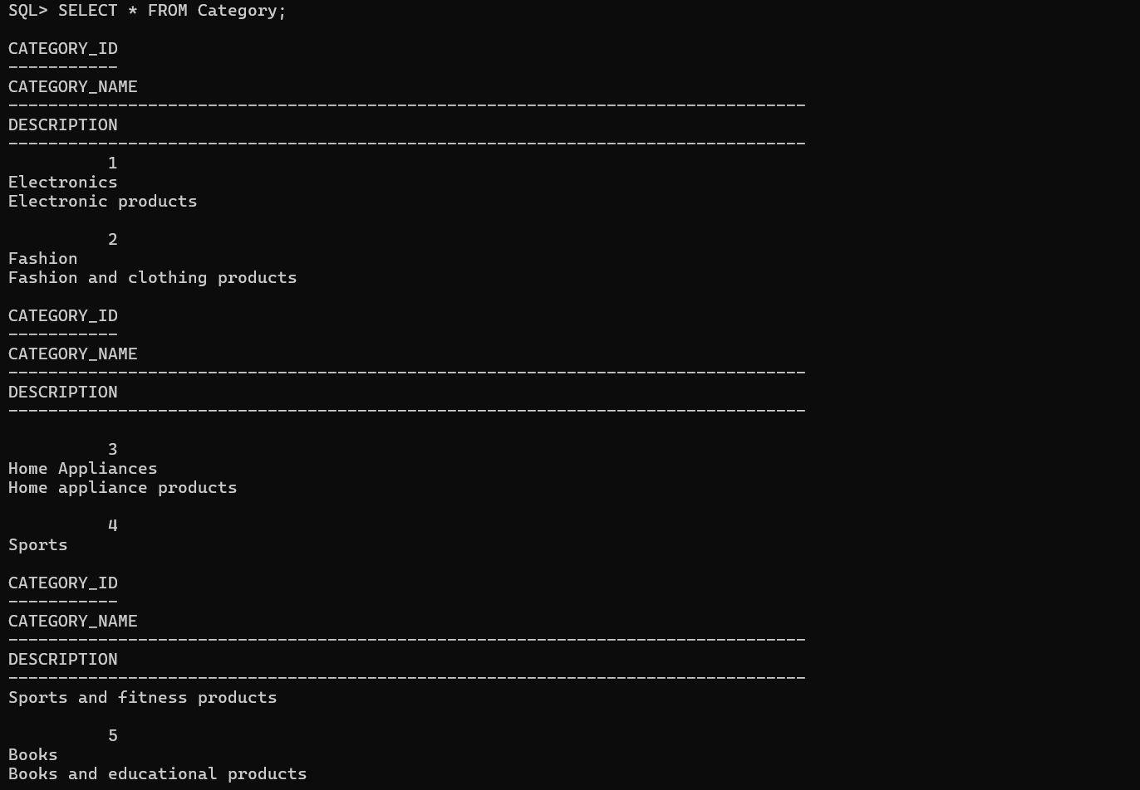
5.2 Display Product Records :
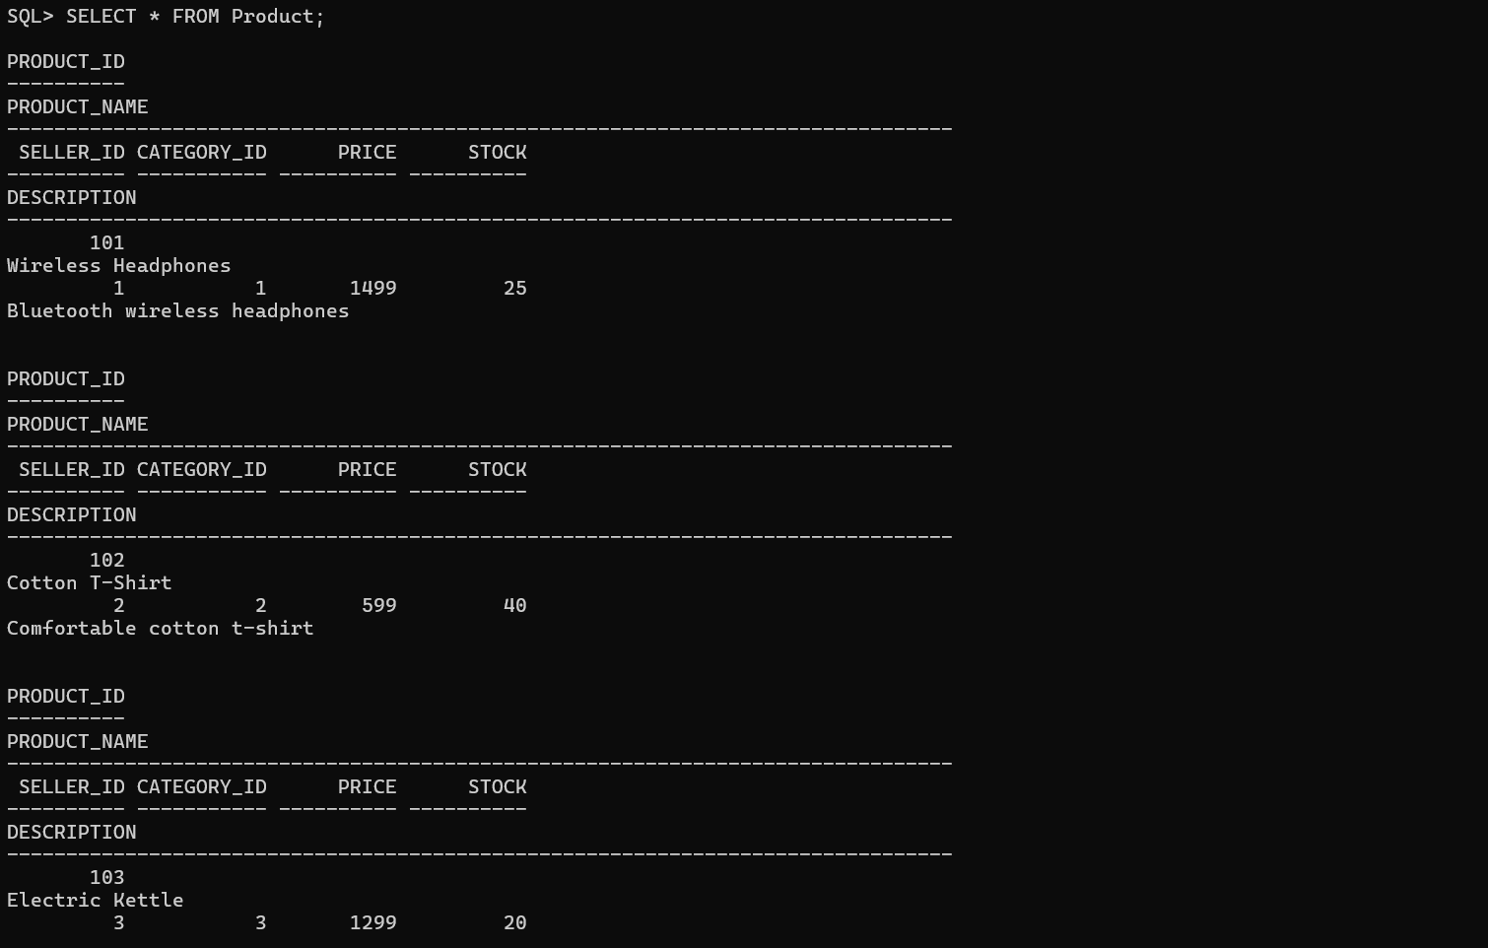
6. Category Update and Delete :
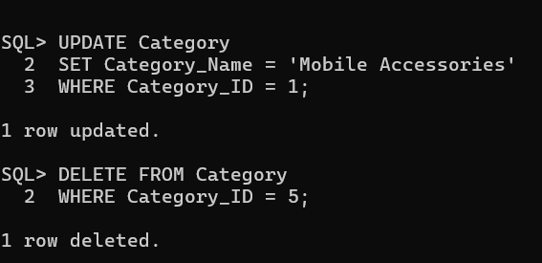
7. Product Update and Delete :
